
Topic: RAINFORESTS
Class: Red Kites Year 5
Summer Term A. 2026
Key vocabulary
Biodiversity | The wide range of living things on  the Earth.
Country | A nation with its own Government
Continent | The world’s main continuous pieces  of land, e.g. Africa, Asia, Europe
Climate | The weather and temperature usually found in an area  over a long period of time
Deforestation | The action of clearing a wide area  of trees.
Ecosystem | A community of plants and animals  That depend upon each other to  Survive.
Habitat | The natural home or environment of  An animal, plant or organism.
Humid | Having a high level of moisture in  The air
Interdependent | When or more people or things rely  on each other.
Rainforest | A dense forest, normally found in  Tropical areas with high rainfall.  Generating much of the world’s  Oxygen.
Skills
Locate the Equator on a map, atlas and globe and draw conclusions about the climates of countries on the Equator and on the tropics.
Ask questions e.g. what is this landscape like? What is life like there? Use and explain the term ‘climate zone’
Identify the different climate zones.
Ask questions and find out what affects the climate.
Children to ask questions about global warming.
Discover the cause of global warming and research the implications. • Reach reasoned and informed solutions and discuss the consequences for the future

Key knowledge or ideas

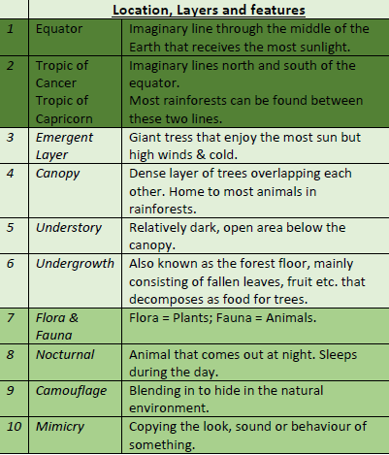

People or places
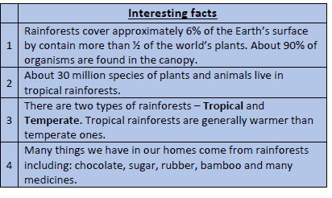
Agreed real life outcome
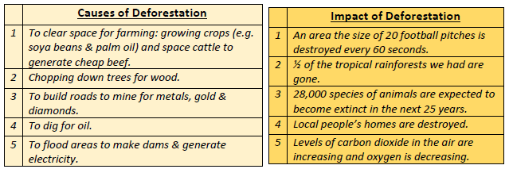

Diagrams or maps


